COLLEGE VISION

Emerge as a center of excellence for professional education to produce high quality engineers and entrepreneurs for the development of the region and the Nation.

COLLEGE MISSION
MI1: To become an ultimate destination for acquiring latest and advanced knowledge in the multidisciplinary domains.
MI2: To provide high quality education in engineering and technology through innovative teaching-learning practices, research and consultancy, embedded with professional ethics.
MI3: To promote intellectual curiosity and thirst for acquiring knowledge through outcome-based education.
MI4: To have partnership with industry and reputed institutions to enhance the employability skills of the students and pedagogical pursuits.
MI5: To leverage technologies to solve the real-life societal problems through community services.

Workshop on Graphic and Website Design
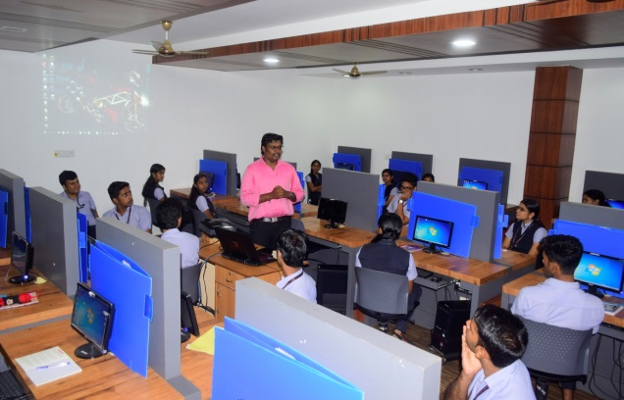

DEPARTMENT VISION
To produce competent professionals with research and innovative skills, by providing them with the most conducive environment for quality academic and research oriented undergraduate education along with moral values committed to building a vibrant nation
DEPARTMENT MISSION
MD1: Provide a learning environment to develop creativity and problem-solving skills in a professional manner.
MD2: Expose to the latest technologies and tools used in the field of computer science.
MD3: Provide a platform to explore the industries to understand the work culture and expectations of an organization.
MD4: Enhance Industry Institute Interaction program to develop entrepreneurship skills.
MD5: Develop research interest among students which will impart a better life for the society and the nation.

On 07th and 08th january ,2020, as part of XMERON, department of computer science and engineering conducted a workshop on Graphic and Website Design for S5 CSE Students. The workshop was handled by Mr.Vishak.V.K ,Graphic Designer and trainer, Coimbatore. The event was hosted at Computer Lab in New Block Fourth floor from 9.00 AM to 4.00 PM in that two days.
Workshop on Mobile App Development
A workshop on Mobile App Development was organized by department of cse in association with Xmeron on 6-02-2020. The workshop was handled by Mr.A.Ramkumar,Android Trainer & developer, Madurai.The workshop was open for all the students of the department of computer science.

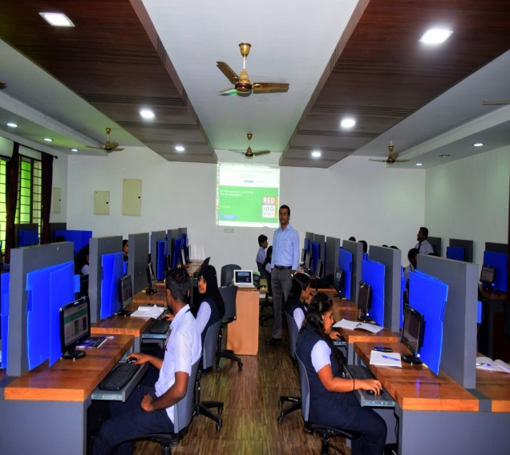
The session was really intresting for the students.Dr.Reshmi B ,Head of the Department, delivered their felicitations and suggestions for the association activities. The Chief Guest distributed participation certificate to the students.
Webinar on Digital investigation and cyber forensics
Department of Computer science and Engineering organized a webinar on Deep learning on 22nd May 2020.The event was conducted through online due to this pandemic condition of covid 19.The Webinar is open to all students and faculties from the instituition.

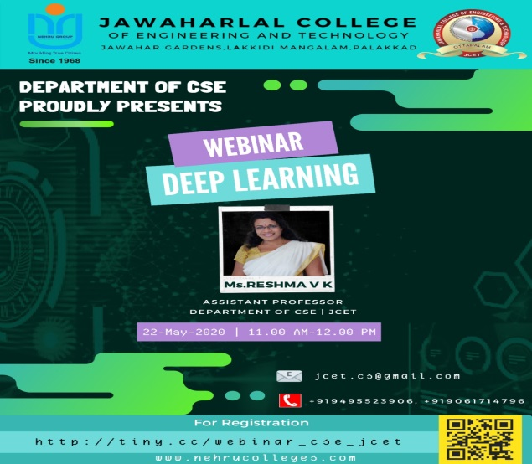
Webinar on Digital investigation and cyber forensics
Department of Computer science and Engineering organized a webinar on Digital investigation and cyber forensics on 29th May 2020.The event was conducted through online due to this pandemic condition of covid 19.The Webinar is open to all students and faculties from the instituition.
The field of digital forensics has expanded to include network forensics as well, and includes such areas of expertise as investigating network security breaches, hacking attempts, and data theft.The webinar also covered by discussing several tools related to digital forensics .
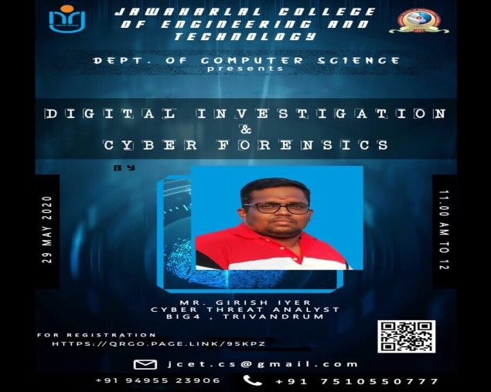
STAFF ACHIEVEMENTS
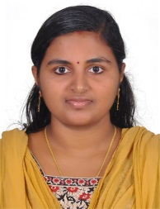
Ms.Sreekala R Presented a paper on Data anonymization on mapreduce –cloud using optimized using TPDS in international virtual coference on recent innovations in science and technology on May 2020
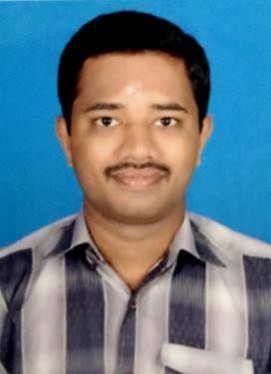

Mr.Manoj M Pulished a paper on “Unsubstantiated Anthropological motion exploration for smart mobile robots” in International Journal for scientific research and development on march 2020
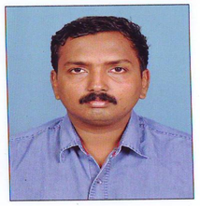
Mr.Shyjith M B Pulished a paper on "Optimized support vector neural network and contourlet transform for image steganography" in Evolutionary Intelligence Springer Link (Scopus Indexed)
Pulished a paper on Optimized and Dynamic Selection of Cluster Head Using Energy Efficient Routing Protocol in WSN.in Wireless Pers Commun (2020)Springer Link(Science Citation Index)
Pulished a paper on "Chicken-Moth Search Optimization-Based Deep Convolutional Neural Network for Image Steganography" in Scalable Computing: Practice and Experience, (Scopus Indexed)

Ms.Ramya T V Pulished a paper on “Unsubstantiated Anthropological motion exploration for smart mobile robots” in International Journal for scientific research and development
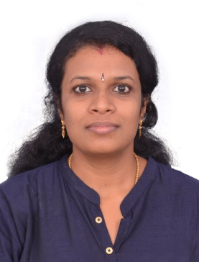
Ms.Reshma V K Pulished a paper on "Pixel Prediction-Based Image Steganography by Support Vector Neural Network" in The Computer Journal :Oxford University Press (Science Citation Index).
Pulished a paper on "Optimized support vector neural network and contourlet transform for image steganography" in Evolutionary Intelligence Springer Link (Scopus Indexed)

Pulished a paper on "Chicken-Moth Search Optimization-Based Deep Convolutional Neural Network for Image Steganography" in Scalable Computing: Practice and Experience, (Scopus Indexed)
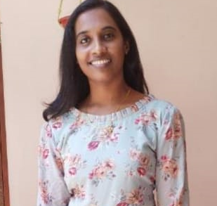
Ms.REEJA R RAJAN Pulished a paper on “Unsubstantiated Anthropological motion exploration for smart mobile robots” in International Journal for scientific research and development

